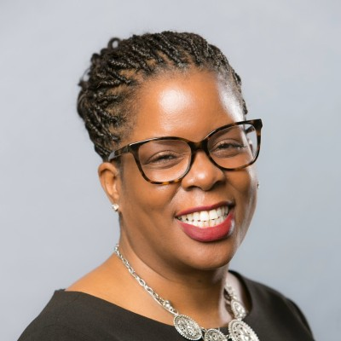

**Jill Banks**

**Director of Learning Operations**

Jill Banks is responsible for creating consistent learning experiences that leverage technology, next- generation educational science and data analytics to drive cable workforce technical expertise and ROI for the industry.

Prior to joining SCTE in 2017, Jill spent over 30 years serving in various learning and development capacities with multiple Fortune 500 companies, including General Electric, American International Group (AIG), and Farmers Insurance. With SCTE, she has supported double-digit growth in course material and has been instrumental in the organization’s use of 3D simulations and other technologies to improve knowledge retention, reduced training time, brought in a new college program, and increased the impact on the organization. Her philosophy is that every encounter is a teachable moment at which persons can learn, develop, and grow regardless of age, profession, or titles.

In addition to her responsibilities with SCTE, Jill serves on the Board of Directors for Chestnut Hill College. She has served on the Advisory Boards for the Farmers Insurance Group’s Women’s Inclusion Network supporting mentoring and participated as a mentor for Big Brothers Big Sisters. In addition, she has volunteered for numerous community events, including Susan B. Komen Race for the Cure, Ronald McDonald House and Martin Luther King, Jr. Day of Service.

Jill holds a Bachelor of Arts degree in Political Science from Millersville University, a master’s in business administration from DeVry University and is pursuing a Doctorate in Education from Capella University.